Dart Score Tracker – Development Review

G00347352 - aaron hannon

2019

# Review of Development:

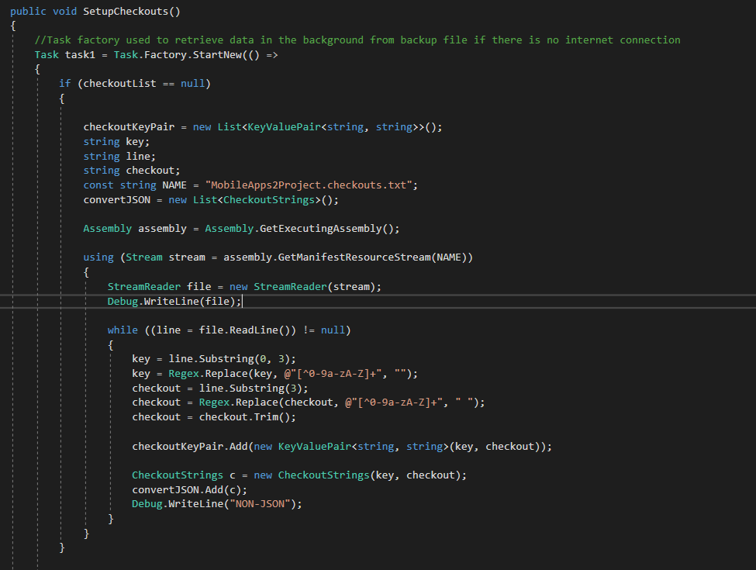When I started this project I quickly realised I gave myself too much to do in my initial design document, which is also included in the git repos. I said that the application would have these gamemodes “Standard 701,501,301, cricket and Around the clock.” but I only managed to implement the first 3. I also said it would have up to 4 players but in at the end I did not have enough time to add more players. In the original document I said it would be quite difficult to figure out the checkout string that lets the player know what they have to score to win the leg in the next round but luckily I found a Text file online with all the necessary data to do this. However it was in the incorrect format and would have taken too long to edit by hand so, I wrote a method to convert it to a JSON format.

This worked perfectly but I wanted to make things more challenging for myself seeing that I found this data online. I decided to store all my data on MLab which is a mongo database that is free to use. In my original document I was going to store data locally but I changed my mind after finding the Text file. So I installed a NUGET package and wrote a MongoService class to handle all the connections between the different collections on the database.

As for UI changes I stuck to the plan more or less. I didn’t like the Xamarin toolbar so I made a simple home myself that is similar to the design I had in mind. In conclusion, time was a huge constraint even though I started committing soon after receiving the project brief I had to remove features because of this but I added some too like the mongo database that stores all the checkout data and all the previous game data/ game history

NOTE: I have a habit of committing in large chunks that’s why I don’t have many commits on my github.

## DARTS DATA REFERENCE:

<https://github.com/rg3/darts/blob/master/checkouts-3darts.txt>